**Air Traffic Control (M6932)**

**Assignment 1 (100 marks = 10% Weightage)**

**Date Release 28th Feb 2020**

**Date Due 8th March 2020**

**Student Name :_____________________________**

**Student ID :_____________________________**

Q1: Use the attached IFR Enroute Low Altitude Chart for region around Chicago O’Hare Airport to answer following questions:

1. A VOR/DME is located at Chicago O’Hare
   1. What is the ICAO identifier for the VOR/DME_______________
   2. What frequency and channel does the pilot tune to use the VOR/DME ______Mhz, Channel_____
2. The 090 degree radial outbound from the Chicago O’Hare VOR along with the 21 nm range from the Chicago O’Hare DME defines an intersection.
   1. What is the name of that intersection________________
3. The 089 degree radial outbound from the Chicago O’Hare VOR along with the 14 nm range from the Chicago O’Hare DME defines an intersection
   1. What is the name of that intersection_______________
4. The FARMM intersection is north-west of the Chicago O’Hare VOR/DME on the 314 degree radial outbound of the VOR and 29 nm range from DME.
   1. The FARMM intersection is located on which airway running approx. east-west?_____________
5. For Airway V116 on 090 degree radial outbound from the Chicago O’Hare VOR/DME
   1. What is the Minimum Enroute Altitude__________
   2. What is the Minimum Obstruction Altitude_________

(**Total** **16 Marks, 2 Marks each**)

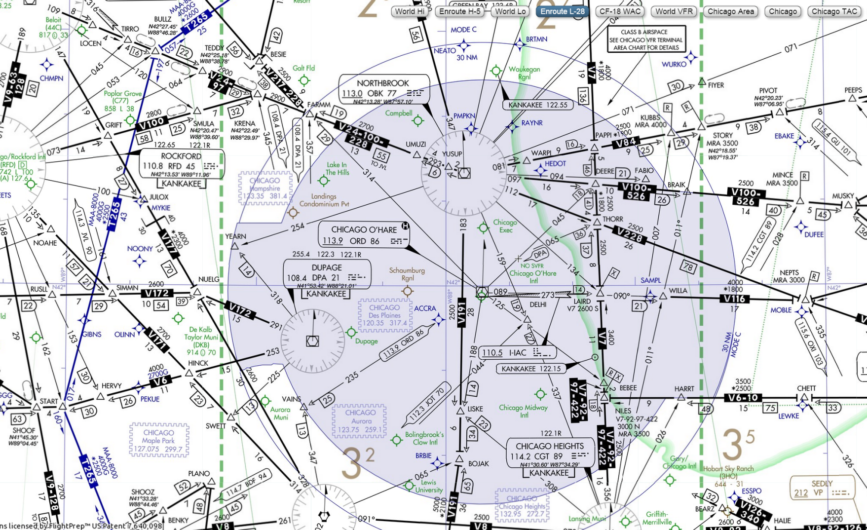

Q2: Match the OBI readings with the eight (8) aircraft positions shown on VOR radial/course: You may indicate using an arrow connecting aircraft position to their respective OBI displays.

**16 Marks (2 Mark each)**

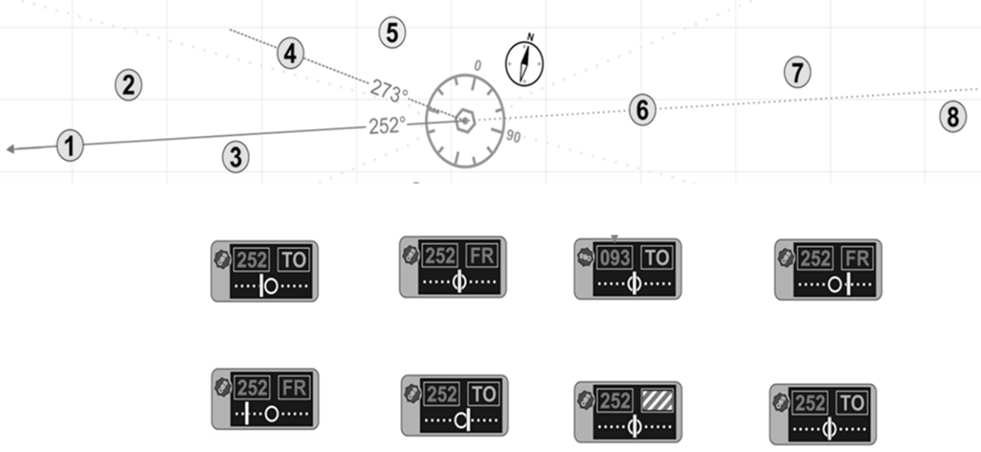

Q3: Download the Investigation Report by German Federal Bureau of Aircraft Accidents

Investigation into Ueberlingen/Lake of Constance/Germany Accident involving Boeing

B757-200 and Tupolev TU154M which lead to loss of 71 lives

http://cfapp.icao.int/fsix/sr/reports/02001351_final_report_01.pdf

**[14 Marks, 7 marks each]**

1. Draw the labelled incident diagram of the accident showing the time stamped sequence of events. Follow the example of TCAS incidents shown in the Slide 95 of Lecture Air Traffic Surveillance Systems. Please include time stamp with each event box.
2. Explain the following contributing factors in the Ueberlingen air crash
3. Single Person Operation Procedure
4. Ground Radar downgrade
5. Monitoring of two frequencies by one ATC
6. Ground to Ground Communication
7. TCAS

Q4: For the given STAR chart below, answer the following Questions:

**[17 Marks]**

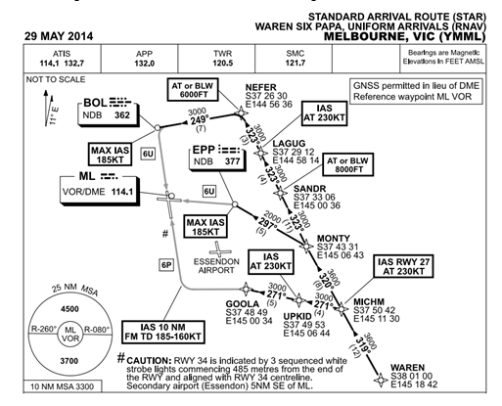



Q5: For the Williamsport Regional Airport show in the map below, please answer the following questions : **[18 Marks]**

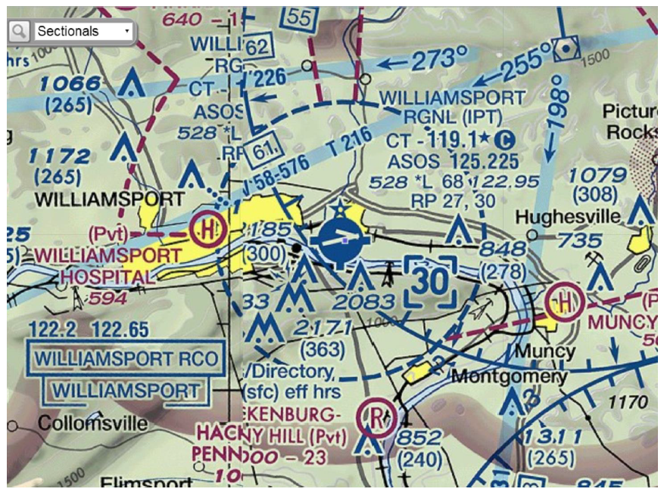

1. Does it have rotating beacon from Sunset to Sunrise?
2. Is fuel available at this airport?
3. Does it have Flight Services facility?
4. What is the control tower primary frequency?
5. Does this airport operate full time or part time?
6. Is runway lighting operational from sunset to sunrise?
7. Is it a public use airport or private use airport?
8. Which Runways at this airport have right traffic pattern?
9. What is the length of longest runway at this airport in hundreds of feet?

Q6: **[19 Marks]**

a) A Southwest Airline Airbus A320 departs Washington Dulles (IAD) airport for Los Angeles (LAX). The pilot requests an initial altitude to be flown. Which of the two altitudes below is allowed for this flight? **[4 Marks]**

i. 34,000 feet

ii. 35,000 feet

Explain the reason for your selection.

b) An aircraft traffic controller separates traffic in the Singapore Airspace using SSR only, without its associated primary radar. If there are two aircraft located 165 nm and two aircrafts located 45 nm from the radar antenna, what is the minimum horizontal separation used in the two cases? (Hint: Consult AIP Singapore) **[4 Marks]**

c) A pilot reports to ATC to be in cruise at flight level 370 over Arizona USA. What is the altitude of this aircraft above sea level? What is the general direction of flight (i.e., North, South, East, and West) ? Explain **[4 Marks]**

d) When operating in the Singapore Flight Information Region, no aircraft should file a flight plan to cruise at FL115, FL120 and FL125. What is the reason for this restriction? Explain. **[4 Marks]** (Hint: Consult AIP Singapore)

e) Name the six airways that crosses through Singapore Airspace Sector 2E.

**[3 Marks]** (Hint: Consult AIP Singapore)